Social Interaction: Observation Form and Rubric
Student Name: ____________________
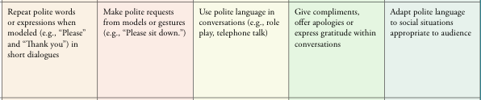

Beginning of Unit Date: _______________ Rubric Score: ____________

Activity | Observation Notes | Vocabulary &  Sentence Starters used

Midpoint of Unit Date:_______________ Rubric Score: ____________

Activity | Observation Notes | Vocabulary &  Sentence Starters used
End of Unit Date:_______________ Rubric Score: ____________
Activity | Observation Notes | Vocabulary &  Sentence Starters used

